Decision Support Tool – Screening Criteria
All criteria in Tables 1 and 2 of the Decision Support Tool are intended to help practitioners determine whether an area meets the Pan-Canadian standards and is therefore eligible to be reported as a Protected Area or an “Other Effective Area-based Conservation Measure" (OECM) under the pan-Canadian standards. Criteria in Table 1 apply similarly to both Protected Areas and OECMs. Criteria in Table 2 help to both define and distinguish between Protected Areas and OECMs. All criteria in Table 2 must be met at the PA level for an area to be reported as protected, or at the OECM level or combination of OECM and PA levels for an area to be reported as an OECM. This template is intended to be used in conjunction with the decision support tool and detailed interpretation guide.
BASIC INFORMATION
Name of Site | City of London, Environmentally Significant Areas
Designation | Publicly-owned Environmentally Significant Areas in London, Ontario  - The Coves Environmentally Significant Area (and Significant Valleyland in part) in London Plan (City of London Official Plan)  - Kains Woods Environmentally Significant Area (and Significant Valleyland in part) in London Plan (City of London Official Plan); Kains Road River Valley Provincially Significant Life Science Area of Natural and Scientific Interest (in part)  - Kelly Stanton Environmentally Significant Area (and Significant Valleyland in part) in London Plan (City of London Official Plan); Kains Road River Valley Provincially Significant Life Science Area of Natural and Scientific Interest (in part)  - Kilally Meadows Environmentally Significant Area (and Significant Valleyland in part) in London Plan (City of London Official Plan)  - Lower Dingman Environmentally Significant Area (and Significant Valleyland in part) in London Plan (City of London Official Plan)  - Meadowlily Woods Environmentally Significant Area (and Significant Valleyland in part) in London Plan (City of London Official Plan); Provincially Significant Wetland (in part)  - Medway Valley Heritage Forest Environmentally Significant Area (and Significant Valleyland in part) in London Plan (City of London Official Plan)  - Pottersburg Valley Environmentally Significant Area (and Significant Valleyland in part) in London Plan (City of London Official Plan)  - Sifton Bog Environmentally Significant Area in London Plan (City of London Official Plan); Provincially Significant Wetland (in part); Byron Bog Provincially Significant Life Science Area of Natural and Scientific Interest  - Warbler Woods Environmentally Significant Area in London Plan (City of London Official Plan)  - Westminster Ponds / Pond Mills Environmentally Significant Area in London Plan (City of London Official Plan); Provincially Significant Wetland (in part); Westminster Ponds Provincially Significant Life Science Area of Natural and Scientific Interest
Province/Territory | Ontario
Year of Establishment / Securement | 1935 – The Coves Environmentally Significant Area  2001 – Kains Woods Environmentally Significant Area  2007 – Kelly Stanton Environmentally Significant Area  1960 – Kilally Meadows Environmentally Significant Area  1992 – Lower Dingman Environmentally Significant Area  1983 – Meadowlily Woods Environmentally Significant Area  1978 – Medway Valley Heritage Forest Environmentally Significant Area  1960 – Pottersburg Valley Environmentally Significant Area  1977 – Sifton Bog Environmentally Significant Area  1982 – Warbler Woods Environmentally Significant Area  1971 – Westminster Ponds / Pond Mills Environmentally Significant Area
Area (ha) | 739.6 Hectares in total (607.8 ha owned by City of London, 118.2 ha owned by UTRCA and 13.4 ha crown riverbed)  The Coves Environmentally Significant Area (City of London – 47.7 ha)  Kains Woods Environmentally Significant Area (City of London – 28.3 ha)  Kelly Stanton Environmentally Significant Area (City of London – 5.6 ha)  Kilally Meadows Environmentally Significant Area (City of London – 109.1 ha, UTRCA – 23.4 ha, Crown riverbed – 13.4 ha)  Lower Dingman Environmentally Significant Area (City of London – 20.9 ha)  Meadowlily Woods Environmentally Significant Area (City of London – 59.9 ha)  Medway Valley Heritage Forest Environmentally Significant Area (City of London – 106.5 ha, UTRCA – 27.6 ha)  Pottersburg Valley Environmentally Significant Area (City of London – 14.5 ha)  Sifton Bog Environmentally Significant Area (City of London – 11.7 ha, UTRCA – 30.1 ha)  Warbler Woods Environmentally Significant Area (City of London – 40.2 ha)  Westminster Ponds / Pond Mills Environmentally Significant Area (City of London – 163.4 ha, UTRCA – 37.1 ha)
Management Authority | Corporation of the City of London, City Planning section
Explanation of Management Authority (optional) | The Corporation of the City of London (the City) owns the majority of the publicly owned Environmentally Significant Area (ESA) lands in London with portions of some of the ESAs owned by the Upper Thames River Conservation Authority (UTRCA), as they were co-operatively acquired under Scheme 43 to acquire floodplain lands. The original Scheme 43 agreement between the City and the UTRCA dates to 1965 and provides for the ongoing management of lands owned by the UTRCA by the Corporation of the City of London. Since 2002 the City has funded a contract for the UTRCA to provide hands-on management for protection of the ESAs consistent with City policies, guidelines, by-laws and Conservation Master Plans.
Governance Type (CPCAD type) | Government - subnational
Legal Basis / mechanism(s) | Legal (P- Provincial, F- Federal)  Mechanisms:  Conservation Authorities Act – P; Environmental Assessment Act – P; Mining Act – P; Municipal Act – P; Planning Act – P  There are several other Federal or Provincial legislative mechanisms referred to in the “Effective Means 1” section of the assessment. While not reflected in this assessment in greater detail, the Federal and Provincial environmental legislation applies to, and is followed, on these sites.  City of London By-laws  Zoning By-law No. Z-1 (City of London 2011)  Parks and Recreation Area By-law (City of London 2018)  Policy  Provincial Policy Statement (PPS) under the Planning Act (MMAH 2014)  London Plan (City of London Official Plan 2016)  Environmental Planning Policy Manual for the Upper Thames River Conservation Authority (UTRCA 2006)  Plans, Strategies and Guidelines  Conservation Master Plan for the Coves ESA, 2014  Kilally Open Space Master Plan, 1999  Ecological Restoration Plan for Kilally Meadows ESA, 2019  Meadowlily Woods ESA Conservation Master Plan, Phase 1, 2019  Natural Heritage Inventory and Evaluation, Medway Valley Heritage Forest ESA, 2015  Pottersburg Valley ESA Ecological Restoration Plan, 2019  Sifton Bog ESA Conservation Master Plan, 2000  Ecological Restoration Plan for Westminster Ponds/Pond Mills ESA, Saunders Cabin Area Ecological Restoration Plan, 2016  Westminster Ponds/Pond Mills ESA: Ecological Inventory and Management Zone Report Volume 1, 2015  Westminster Ponds / Pond Mills ESA Conservation Master Plan Update, 2005  Environmental Management Guidelines (City of London 2007)  Guidelines for Management Zones and Trails in ESAs (City of London 2016)  London Invasive Plant Management Strategy (City of London 2016)  A Wetland Conservation Strategy for Ontario 2017-2030 (MNRF 2017b)  Designations  Environmentally Significant Area (ESA): These areas are large features of London’s Natural Heritage System, typically represented by a complex of wetlands, woodlands, significant wildlife habitat or valleylands. These areas are mapped and designated for protection under the London Plan (the City of London Official Plan) as they meet a number of ecological criteria under the London Plan and some include Provincially Significant Wetlands (PSW) and Life Science Areas of Natural and Scientific Interest (ANSI) within their boundaries (City of London, 2016).  Provincially Significant Wetlands (PSWs): PSWs are identified by the Government of Ontario as being the most valuable wetlands. The PPS prohibits development and site alteration in all PSWs throughout much of southern and central Ontario, and provincially significant Great Lakes coastal wetlands anywhere in the province. Development and site alteration is prohibited on lands adjacent to PSWs, unless it has been demonstrated that there will be no negative impacts on the wetlands or their ecological functions (MMAH 2014).  Areas of Natural and Scientific Interest (ANSI): ANSIs encompass unique natural landscapes and/or features that are important for natural heritage protection, appreciation, scientific study, and/or education. ANSIs complement provincial parks and conservation reserves by conserving significant features through means other than regulation and may qualify as protected under the auspices of the PPS (MMAH 2014) or through municipal official plans, land trusts, legal agreements, and other protection mechanisms.
Explanation of legal basis / mechanism(s) (optional) | Only provide description if legal basis or mechanism(s) is very complex or not well understood. This is not necessary for most sites.
Summary of Essential / Relevant natural, social and cultural values | The ESAs are located within the boundaries of the City of London. ESAs are large areas that contain natural features and perform ecological functions that warrant their retention in a natural state. ESAs are large features of the Natural Heritage System, often represented by a complex of wetlands, woodlands, significant wildlife habitat or valleylands. There are species at risk, as well as regionally and locally rare species present including but not limited to Bald Eagle, Bank Swallow, Snapping Turtle, Butternut, Wood Thrush, Eastern Meadowlark. There are three Provincially Significant Wetland (PSW) complexes present including Meadowlily Woods (UT 21), Sifton Bog (UT 3) and Westminster Ponds/Pond Mills Wetland Complex (Ut 7). There are three Life Science Areas of Natural & Scientific Interest (ANSI) present including Kains Road River Valley, Byron Bog and Westminster Ponds. An extensive trail system (~55 km of managed trail) can be found throughout the ESAs for public recreation accompanied by a suite of permitted activities/uses to support conservation of biodiversity. Additional site-specific information on hiking trails, access points, history, landscape, plant communities and restoration activities, wildlife and more can be found in the UTRCA information brochures or in the Literature Cited section of the assessment.

Decision Support Tool – Screening Criteria
STEP 1: STANDARDS COMMON TO PROTECTED AREAS AND OECMS
CRITERIA: | INTENDED EFFECT OF THE CRITERION | SCREENING CHOICE | EVIDENCE-BASED RATIONALE  Rationale/evaluation of how area meets the intended effect of the criterion | OUTCOME
GEOGRAPHICAL SPACE | Demarcates the area to facilitate the in-situ conservation of biodiversity. | A. The geographical space has clearly defined and agreed-upon borders. | Metes and bounds surveys with registered boundaries are on title. The ESAs are well mapped, roads and fences define the edges in some areas, and detailed signage with rules and by-laws are in place at the majority of the access points. The City funded ESA management contract with the UTRCA includes detailed mapping of the ESAs. See Mapping Resources for clearly defined ESA boundaries. | Yes
EFFECTIVE MEANS – 1 | Activities incompatible with the in-situ conservation of biodiversity do not occur and compatible activities are effectively managed. | A. The mechanism(s) provide(s) the ability to prevent incompatible activities and manage all other activities within the area, such that the in-situ conservation of biodiversity can be achieved | The detailed rules in the City’s Parks and Recreation by-law, Zoning by-law etc. are enforced by City by-law staff and the UTRCA ESA Team under the ESA contract to prohibit activities that are incompatible with the in-situ conservation of biodiversity. Hunting, ATVs, and snowmobiling are examples of prohibited activities, enforced to protect the ESAs under City by-laws.  Section 34 of the Planning Act states that Zoning by-laws may be passed by the councils of local municipalities:  Natural features and areas  3.2 For prohibiting any use of land and the erecting, locating or using of any class or classes of building or structures within any defined area or areas,  i. that is significant wildlife habitat, wetland, woodland, ravine, valley or area of natural and scientific interest,  ii. that is a significant corridor or shoreline of a lake, river or stream, or  iii. that is a significant natural corridor, feature or area.  In addition, there are many other layers of legislation, policy, and plans that enable the City and the UTRCA to exclude, control, and manage activities that might impact biodiversity in the management area. All subsurface rights have been extinguished under the auspices of the Mining Act (Statutes of Ontario 1990b). The Planning Act and PPS (MMAH 2014) and other statutes contribute to the mix of protection mechanisms. Accordingly, the City and the UTRCA employ a suite of policies to protect ANSIs, PSWs; significant woodlands; wildlife habitat; species at risk habitat; provincially significant species; and, aquatic ecosystems and fish habitat.  The following policies pertain to wetlands as natural heritage features:  - New development and site alteration is not permitted in PSWs or other wetlands. Some restricted uses may be permitted provided that they are supported by an environmental impact statement (EIS) or assessment.  - New development and site alteration is not permitted in adjacent lands associated with wetlands unless an EIS has been completed, to the satisfaction of the City, with no negative impact on the feature or its ecological function (City of London, 2016).  The following policies pertain to ANSIs as natural heritage features:  - Development and site alteration shall not be permitted in or adjacent to areas of natural and scientific interest unless t has been demonstrated that there will be no negative impacts on the natural features or their ecological functions  For other policies pertaining to the various natural heritage features within Environmentally Significant Areas, refer to the London Plan.  With respect to the UTRCA-owned portions of the ESAs, the Conservation Authority is able to prevent incompatible activities and manage all other activities due to Section 29(1) of the Conservation Authorities Act (Statutes of Ontario 1990a). Section 29 (1) states that:  (1) An authority may make regulations application to lands owned by the authority.  a. regulating and governing the use by the public of the lands and the works, vehicles, boats, services and things of the authority  b. providing for the protection and preservation from damage of the property of the authority  […]  Furthermore, Regulation 136: Conservation Areas – Upper Thames River details prohibited activities or activities requiring permits on lands owned by the Conservation Authority which includes damage or removal of plants, killing or injuring of wildlife, camping, excavating, etc.  Conservation Authorities Act, R.S.O 1990, c. C.27 and s.1 of the act provides that, for the purposes of accomplishing its objects, an authority has power and may enter into a memorandum of understanding with a municipality situated in whole or in part within its area of jurisdiction in respect of program and services that authority will provide on behalf of the municipality; and further in s. 20 that the object of an authority are to provide, in the are over which it has jurisdiction, programs and services designed to further the conservation, restoration, development and management of natural resources other than gas, oil, coal and minerals. Similarly, the City is governed by the Municipal Act, 2001, S.O. 2006, c. 11, Sch. A as amended, and s. 9 of that Act provides that a municipality has the capacity, rights, powers and privileges of a natural person for the purpose of exercising its authority under this or any other Act; and further in section 10(2) to pass by-laws respecting the “economic, social and environmental well-being of the municipality; health and safety and well-being of persons; protection of persons and property; […]”.  Species designated as Threatened or Endangered receive legal protection under the provincial Endangered Species Act (2007) and their habitats (either general or regulated) are protected under the Act as well. Numerous Species at Risk (SAR) are known to occur within some of the ESAs based on background information sources and field work.  Additional statues that provide the City of London and Conservation Authority ability to protect natural heritage includes the Clean Water Act (P), Environmental Bill of Rights (P), Fisheries Act (F), Lakes and Rivers Improvement Act (P), Public Lands Act (P), Trees Act (P), Trespass to Property Act (P), Safe Drinking Water Act (P). These Federal and Provincial statutes apply to, and are followed, on these sites. | Yes
EFFECTIVE MEANS – 2 |  | A. The mechanism(s) compel(s) the authority(ies) to prohibit activities that are incompatible with the in-situ conservation of biodiversity. | The Conservation Authorities Act (Statutes of Ontario 1990a) in conjunction with the PPS (MMAH 2014), other statutes, and associated policies including the London Plan compel the City of London and the Conservation Authority to protect natural heritage features and prohibit activities that are incompatible with biodiversity conservation within London’s ESAs. For example, the PPS provides protection to PSWs, ANSIs, and Significant Woodlands which is then mirrored in the Official London Plan. An additional example, the Wetlands Strategy for Ontario (MNRF 2017b) strengthens agency commitment to wetland protection.  London Plan policy also identifies that “Recreational uses associated with the passive enjoyment of natural features including pathways and trails provided that such uses are designed, constructed and managed to protect the natural heritage features and their ecological functions.”  Section 9 of the UTRCA and City of London ESA agreement states that “All parties shall at all times comply with all provisions of the Conservation Authorities Act and any amendments thereto and any regulations, by-laws and amendments in force from time to time and all rules and regulations pertaining to ESAs as may be enacted from time to time. The Authority shall comply with all applicable federal, provincial and municipal legislation, regulations and by-laws.” | Yes
LONG TERM | The area is permanently protected or conserved and not easily reversed. | A. The mechanism(s) is/are intended to be in effect for the long term and not easily reversed. | London’s publicly owned portions of the ESAs are protected in perpetuity through public ownership and Federal, Provincial and Municipal policies, acts, laws and by-laws.  UTRCA’s owned portions of the ESAs are protected in perpetuity through Conservation Authority ownership and Federal, Provincial and Municipal policies, acts and laws.  The likelihood of Official Plan designations and protections of ESAs to be undone or modified is low, resulting in moderate to high difficulty for reversal. Rezoning would require city council vote, public consultation and could possibly then be subject to an appeal, if passed. Altering or reducing of ESA designations and protections would be inconsistent with the Provincial Policy Statement under the Planning Act. | Yes
TIMING | Biodiversity is protected or conserved year-round. | A. The mechanism(s) is/are in effect year-round | London’s publicly-owned ESAs are protected in perpetuity through public ownership and Federal, Provincial and Municipal policies, acts laws and by-laws year-round.  UTRCA’s owned portions of the ESAs are protected in perpetuity through Conservation Authority ownership and Federal, Provincial and Municipal policies, acts and laws year round. | Yes

STEP 2: STANDARDS THAT FURTHER DEFINE AND DISTINGUISH BETWEEN PROTECTED AREAS AND OECMS
CRITERIA: | INTENDED EFFECT OF THE CRITERION | SCREENING CHOICE | EVIDENCE-BASED RATIONALE:  Rationale/evaluation of how area meets the intended effect of the criterion | OUTCOME
SCOPE OF OBJECTIVES | Objectives have sufficient scope to result in the in-situ conservation of biodiversity. | A. The objectives are for the in-situ conservation of biodiversity as a whole, or for indigenous values accomplished through the in-situ conservation of biodiversity. | London Plan ESA protection policies, Conservation Master Plans and Ecological Restoration Plan recommendations are implemented through annual capital projects and operational activities of the City funded contract with UTRCA which includes the following applicable objectives:  1. Monitoring and enhancing the natural resource:  a. Wildlife and habitat protection  b. Invasive species management, ecological restoration, and, monitoring  c. Native tree planting  d. Coordinate research initiatives  2. Enforcing applicable provincial statutes, regulations, and municipal bylaws:  a. City Parks and Recreation By-laws, including encroachments into City ESA lands  b. Trespass to Property Act  c. Conservation Authority Act  4. Maintaining trail systems:  a. Maintenance and upkeep of built structures (boardwalks, bridges, stairs, docks etc.)  b. Maintenance and upkeep of ESA entrances, and existing trail system  c. Maintenance and upkeep of all required signage  d. Garbage pick-up  5. Coordinating educational programs, events and community projects:  a. Public meetings and presentations  b. Community projects and volunteer groups  c. Provide quarterly and annual reports to the City  Also stated within the ESA management agreement between the UTRCA and the City of London is that the Authority approves the use of its ESA lands for public access as long as such public access is in compliance with the City’s Parks and Recreation By-Law. The City of London also requests that the UTRCA provides Management Activities for all of the ESAs under the agreement whether owned by the City or by the Authority resulting in consistent and concerted management across ESA ownership boundaries | Yes - PA
PRIMACY OF OBJECTIVES | Objectives are such that they result in the in-situ conservation of biodiversity. | A. Conservation objectives are stated as primary and overriding of other objectives. | The London Plan identifies that London’s ESAs are to be protected, conserved, enhanced, and managed for present and future generations.  London Plan objectives for protection of ESAs includes:  - Maintain, restore, monitor and improve the diversity and connectivity of natural heritage features and areas and the long-term ecological function and biodiversity of Natural Heritage Systems.  - Monitor the potential impacts of climate change to maintain the integrity and resiliency of the Natural Heritage System and adjust management activities accordingly.  - Provide opportunities for appropriate recreational activities based on the ecological sensitivities of the area.  Natural heritage planning goals and objectives from the UTRCA Environmental Planning Policy Manual (2006) includes:  - To protect natural heritage features and systems from the potentially negative impacts of development and site alteration.  - To maintain, restore and enhance the biodiversity, ecological function and connectivity of natural heritage features and systems in the watershed. | Yes - PA
GOVERNING AUTHORITIES | The in-situ conservation of biodiversity is not jeopardized by relevant governing authorities. | A. All relevant governing authorities acknowledge and abide by the conservation objectives of the area. | The ESAs are owned by the City of London and UTRCA. The City of London funds a contract for the UTRCA to manage the ESAs to achieve aligned conservation objectives consistent with the London Plan and all Federal, Provincial and Municipal policies, acts laws and by-laws year-round. | Yes - PA
BIODIVERSITY CONSERVATION OUTCOMES | Biodiversity is conserved in-situ. | A. The area is achieving the conservation objectives. | Effective biodiversity conservation is being achieved within these ESA properties through protection, trail management, invasive species management and ecological restoration activities.  The natural heritage policies of the London Plan are based on the underlying principle that biodiversity is a key indicator of ecosystem health. Every 10-20 years ecological inventories, Conservation Master Plans and ecological restoration plans are prepared, implemented and monitored for the ESAs. Measures include three season ecological inventories including searches for Species at Risk, Significant Wildlife Habitat, species counts, weediness scores, wetness, and diversity indices to detect changes in plant and animal species composition.  These ecological inventories identify long term trends and changes in the ESAs, and recommendations including invasive species management and restoration are implemented and monitored in order to protect and enhance ecosystem health and ecological integrity.  The City of London is an identified leader among other municipalities and other levels of government in demonstrating a proactive approach to the management of invasive species in ESAs since 2006. As ecological inventories are updated the species diversity in the ESAs is generally found to be increasing. For example Dillon’s 2015 study of the Medway Valley Heritage Forest ESA found that, “Of the 562 species identified within the MVHF ESA south, 151 had not been previously observed within the MVHF ESA south or surrounding area based on previous studies or historical records.” Referenced in Literature Cited section but also included here are some recent ecological inventories for more detailed results of the achievement of conservation objectives.  Medway Valley Heritage Forest ESA (South)  Sifton Bog ESA  Westminster Ponds ESA  Kilally Meadows ESA  Coves ESA  Meadowlily Woods ESA  In addition to the PPS and the London Plan, City of London policies and plans that protect and enhance the ecological integrity of all ESAs include:  Guidelines for Management Zones and Trails in ESAs  London Invasive Plant Management Strategy  The Federal Invasive Species Centre commended the City of London for the excellent work in protecting the ecological integrity of the ESAs under the London Invasive Plant Management Strategy.  The City of London was recognized with the Lee Symmes Municipal Award by Ontario Nature in 2016 for their commitment to protecting London’s ESAs. The Lee Symmes Municipal Award recognizes municipalities that demonstrate community leadership and exceptional achievement in planning or implementing programs that protect and regenerate the natural environment within a community.  The City of London was recognized with a Service to the Environment Award for the City’s Guidelines for Management Zones and Trails in Environmentally Significant Areas from the Ontario Association of Landscape Architects (OALA).  The City and the UTRCA are nationally recognized for the protection of SAR in London’s ESAs, including protection of aquatic and terrestrial SAR and for contributions to the Recovery Strategy for the False Rue-anemone (Enemion biternatum) in Canada, 2017.  Every five years, the UTRCA produces watershed-level report cards to report on local environmental conditions in each of the 28 sub-watersheds within the Upper Thames watershed. Each report card grades surface water quality, groundwater, wetland coverage, and forest conditions, and provides recommended actions for improvement, and highlights progress made over five years. The grading follows the standardized Conservation Authority Watershed Report Card guidelines developed for watersheds across Ontario (Conservation Ontario 2011/13). | Yes - PA

SUMMARY OF ASSESSMENT
SUMMARY of OUTCOMES / EVALUATION | Screening Outcome: Protected Area (meets all criteria)  If “combination” please identify/explain:  Currently reported to CPCAD/CARTS? Yes, as Protected Area  Reporting Outcome: Report as Protected Area  Total Area (ha) to be reported to CPCAD/CARTS:  735 ha
Identify deficiencies that could be overcome in order to report as PA or OECM | What, if any, actions could be undertaken to meet the Pan-Canadian criteria and standards for reporting?
Lead evaluator / assessor | Linda McDougall, Ecologist, Long Range Planning and Sustainability, City Planning, City of London, London, ON. (T) 519-661-2489 ext. 6494 (E) lmcdouga@london.ca
Communications / Engagement
Approvals | Scott Delyea (Protected Areas Section Policy & Research Analyst, scott.delyea@ontario.ca) ; Corina Brdar (Protected Areas Section A/Senior Ecologist, corina.brdar@ontario.ca)

Tags: Ontario, ON, municipal, Protected Area, PA, Municipality, Valley, Wetland, Woods, Forest, Bog, Pond, Meadows, Environmentally Significant Area, ESA, Significant Valleyland, Provincially Significant Life Science Area of Natural and Scientific Research, ANSI, Provincially Significant Wetlands, PSW, 2020.

Mapping Resources
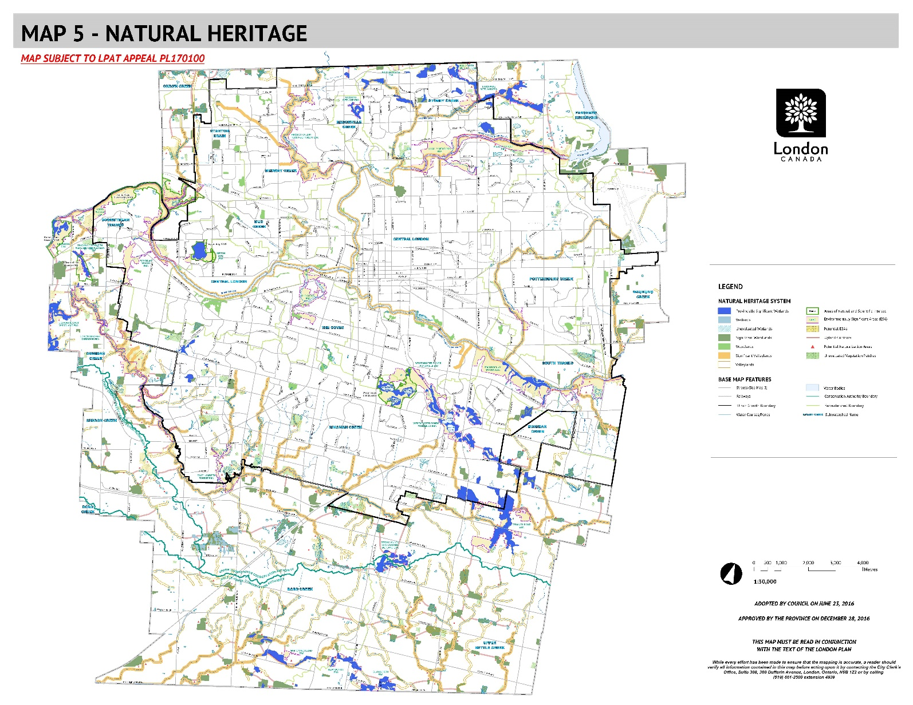
Figure 1. Map 5 Natural Heritage - City of London
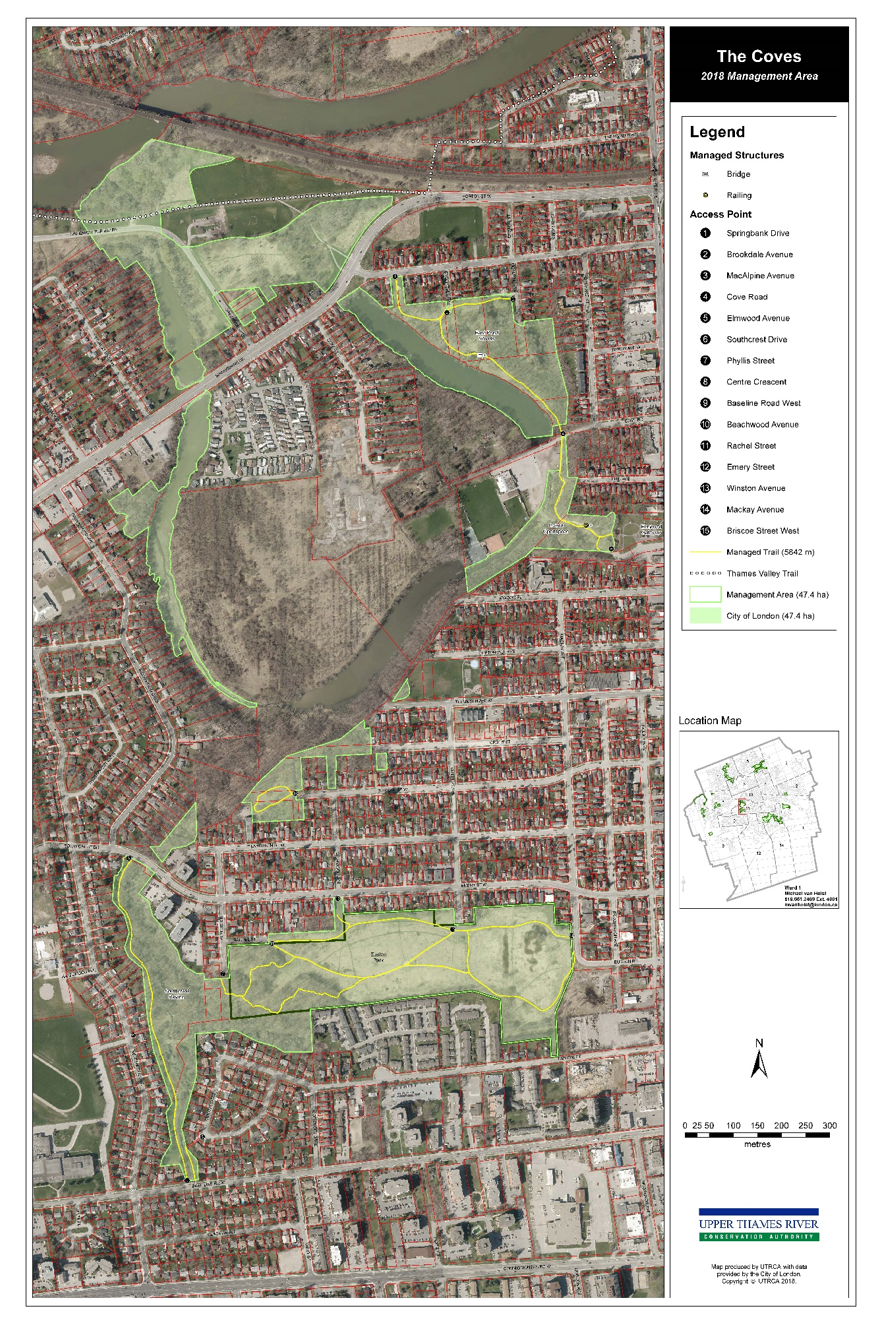
Figure 2 The Coves Environmentally Significant Area
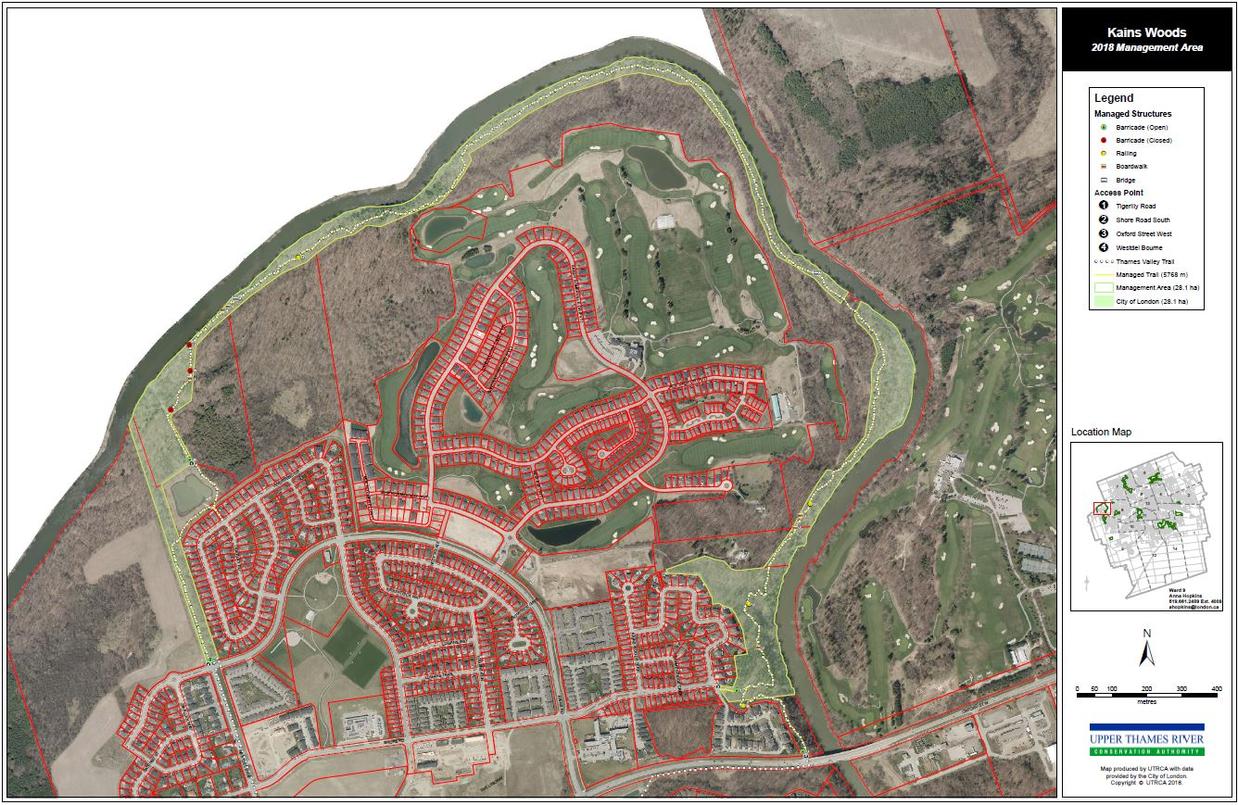Figure 2 Kains Environmentally Significant Area
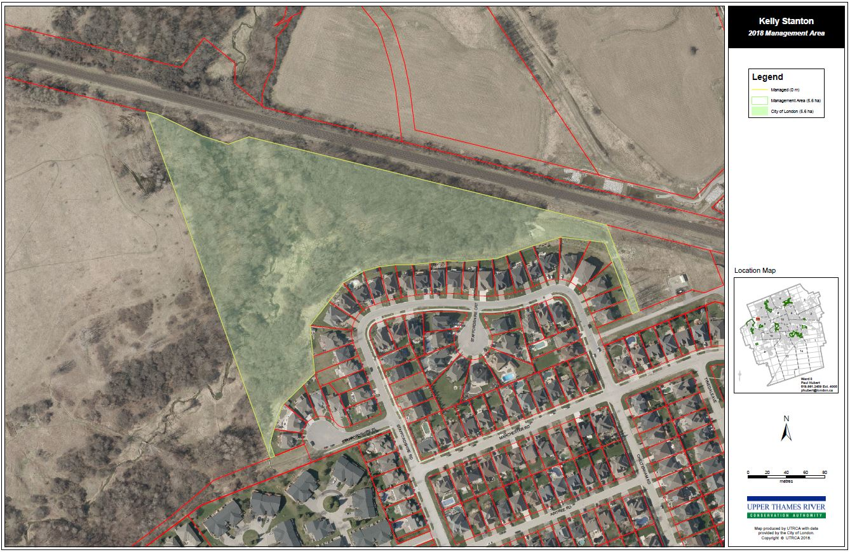
Figure 4 Kelly Stanton Environmentally Significant Area
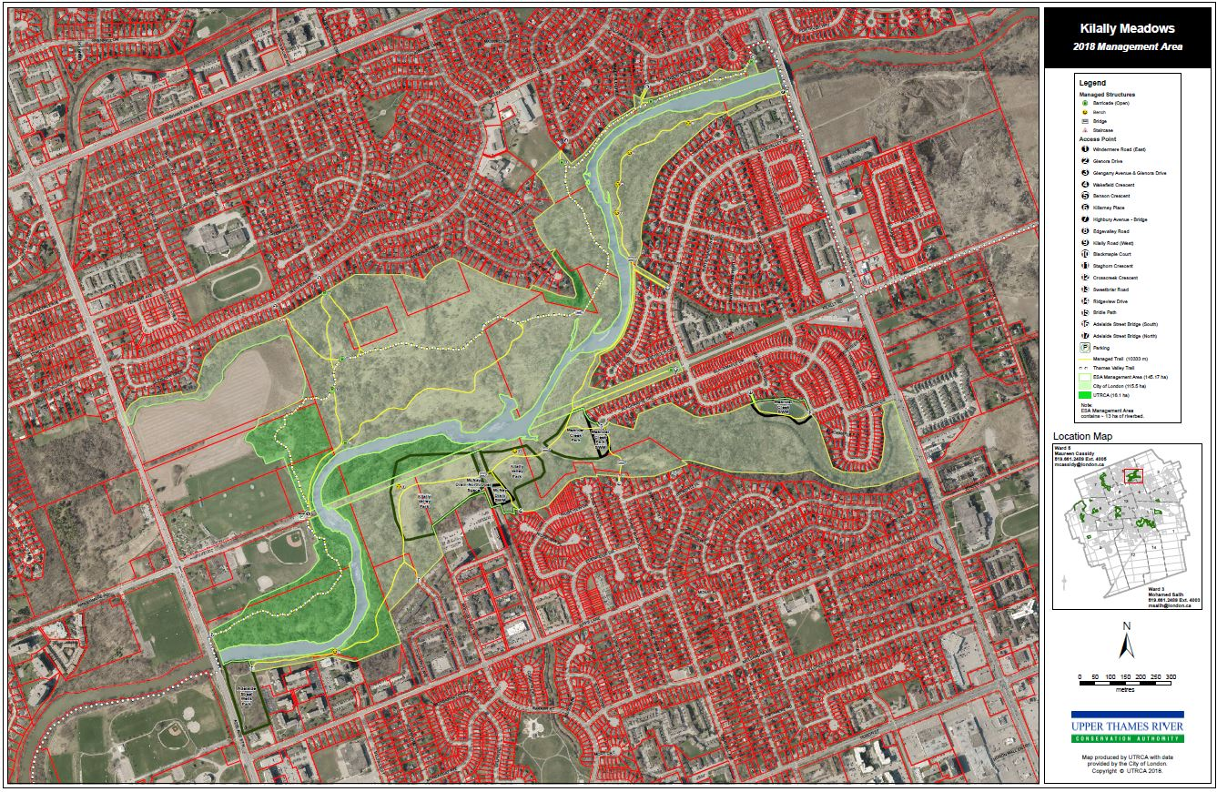
Figure 5 Kilally Meadows Environmentally Significant Area
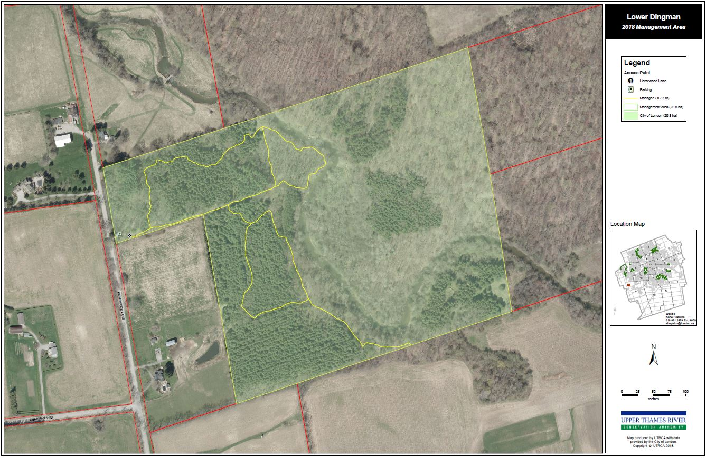
Figure 6 Lower Dingman Environmentally Significant Area
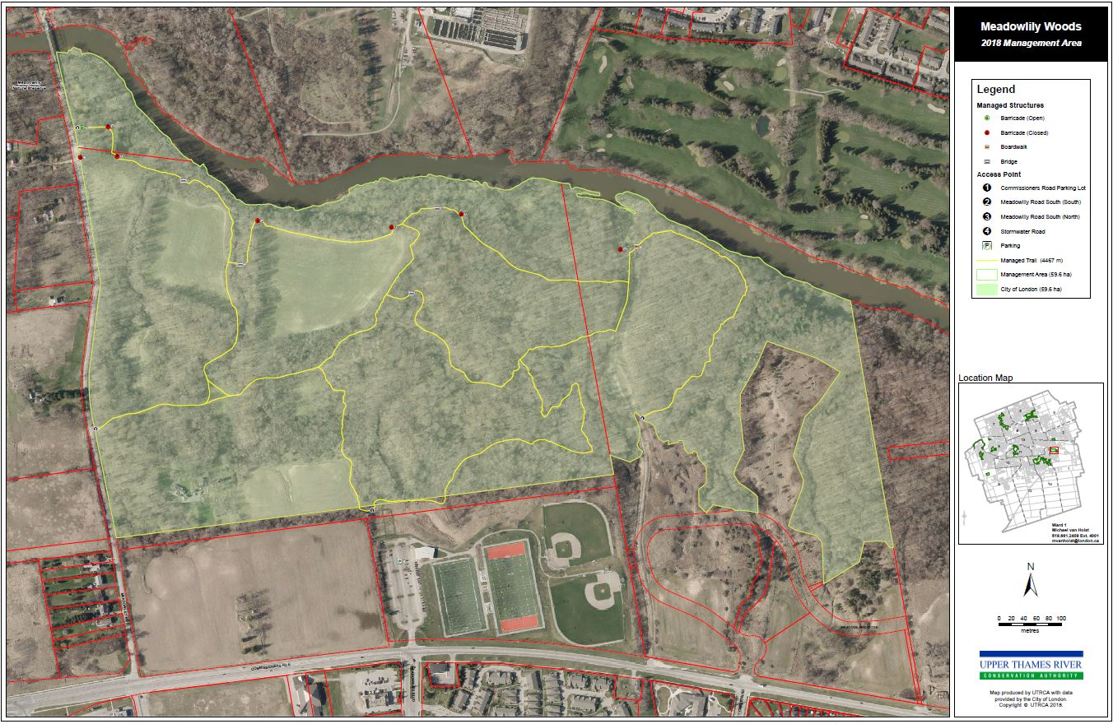
Figure 7 Meadowlily Woods Environmentally Significant Area
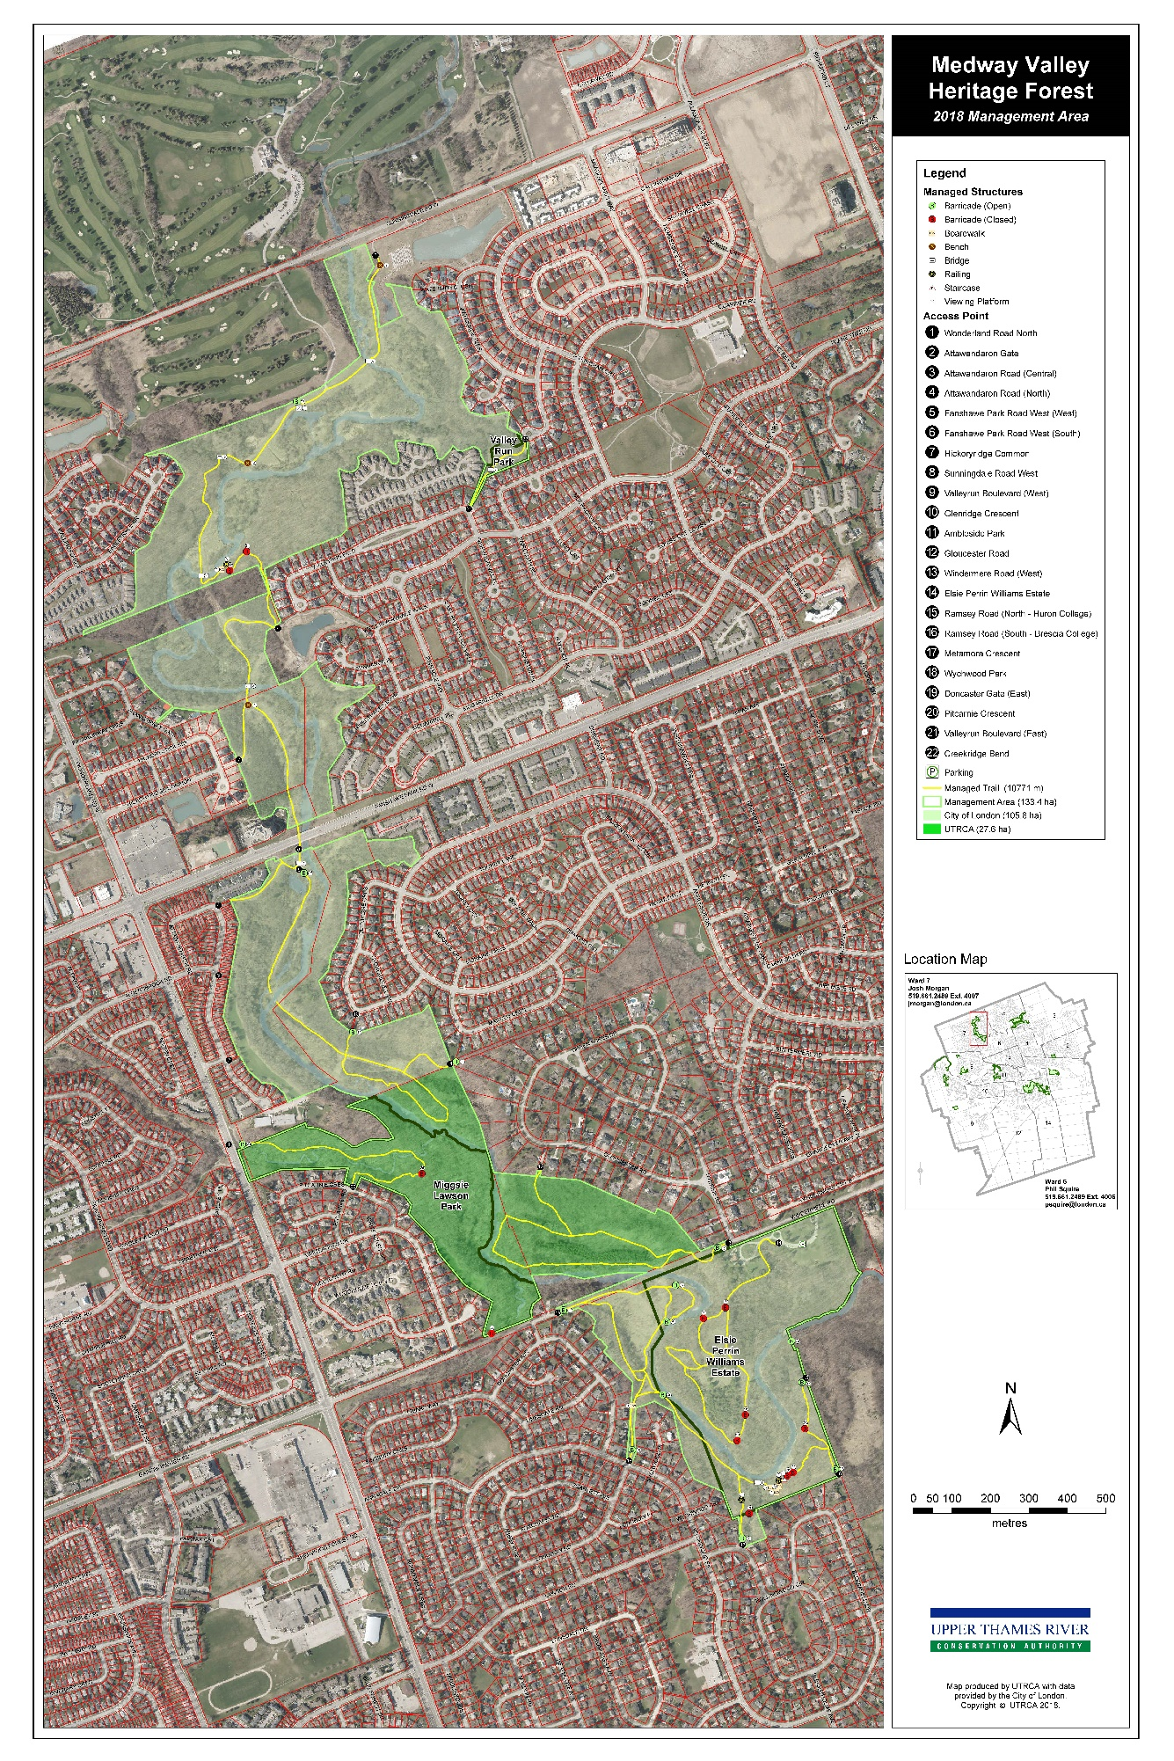
Figure 8 Medway Valley Environmentally Significant Area
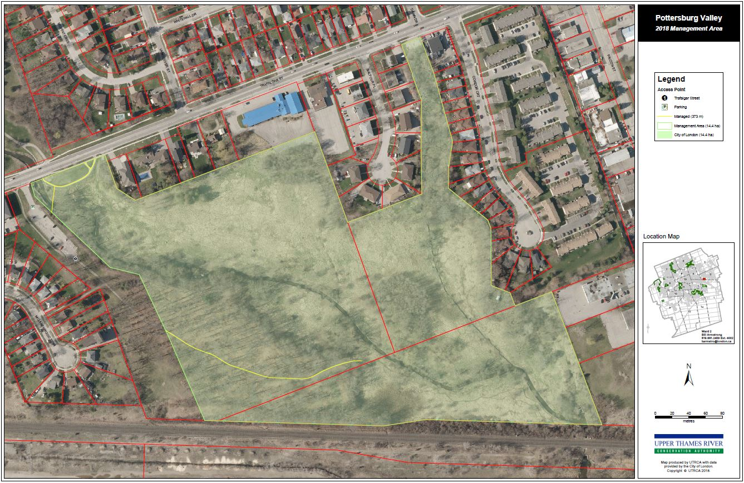
Figure 9 Pottersburg Valley Environmentally Significant Area
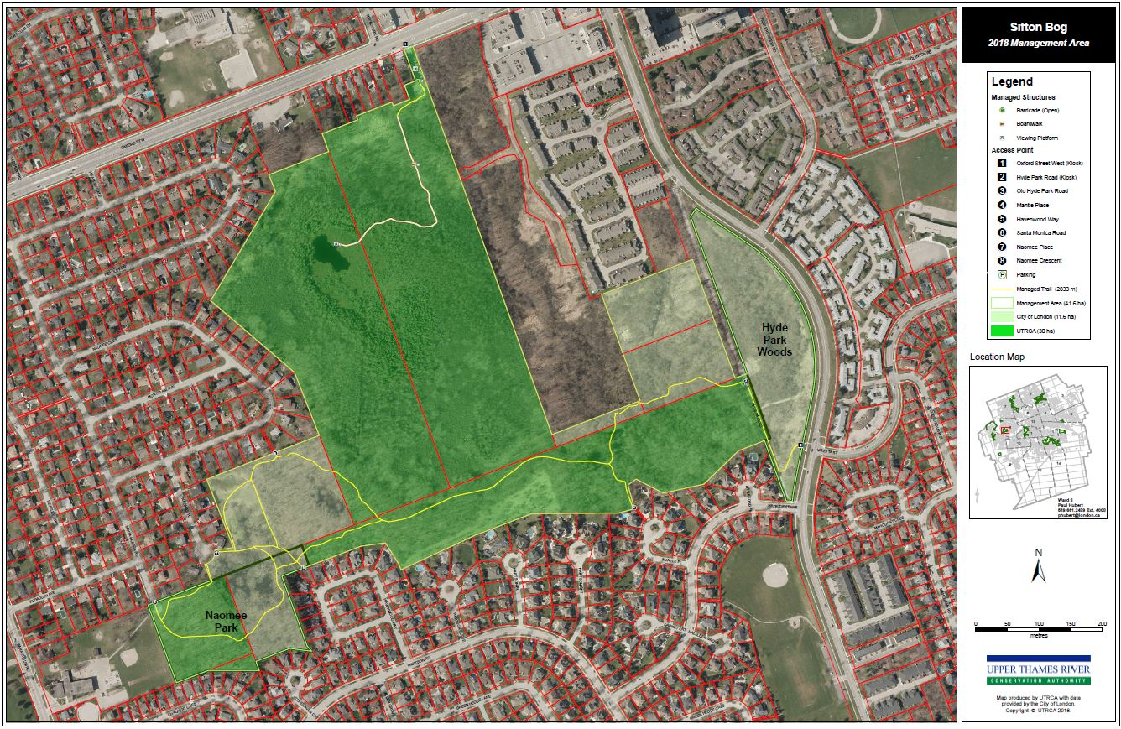
Figure 10 Sifton Bog Environmentally Significant Area
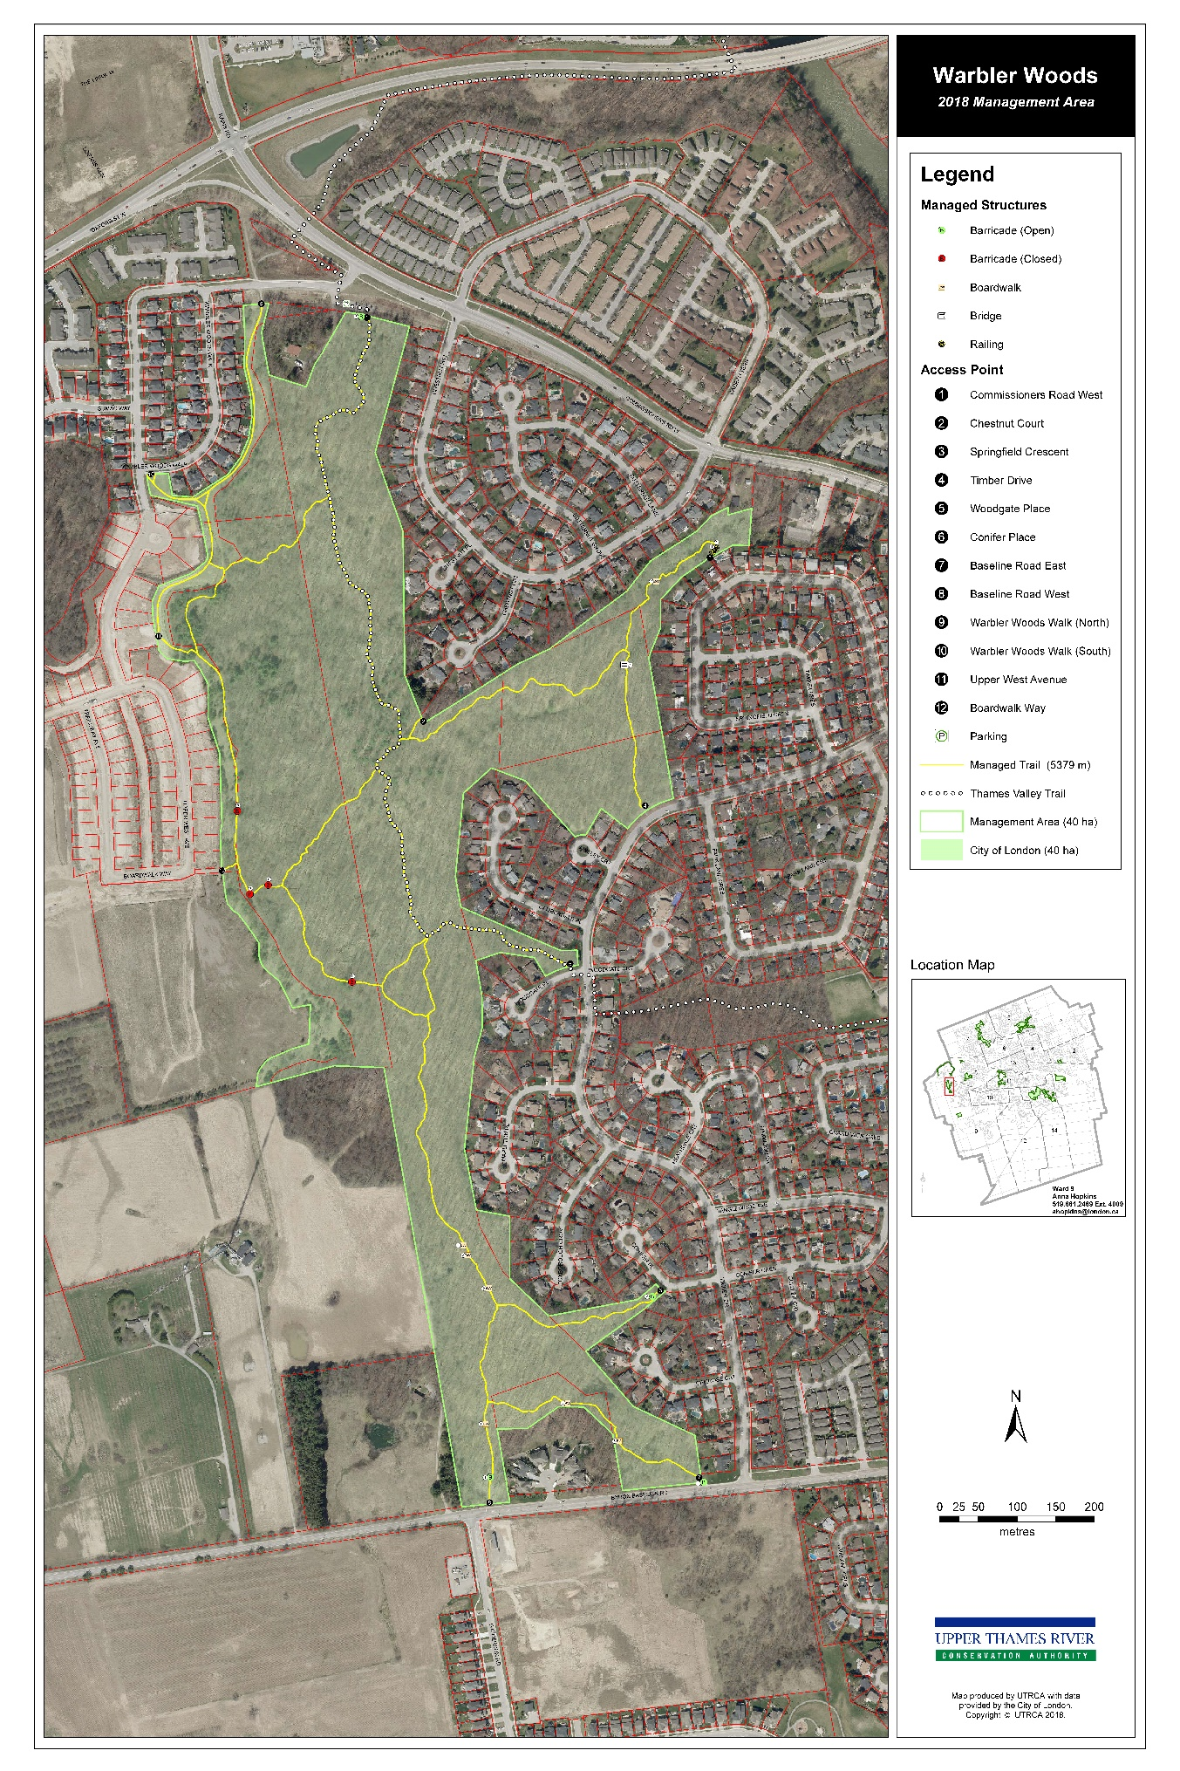
Figure 11 Warbler Woods Environmentally Significant Area
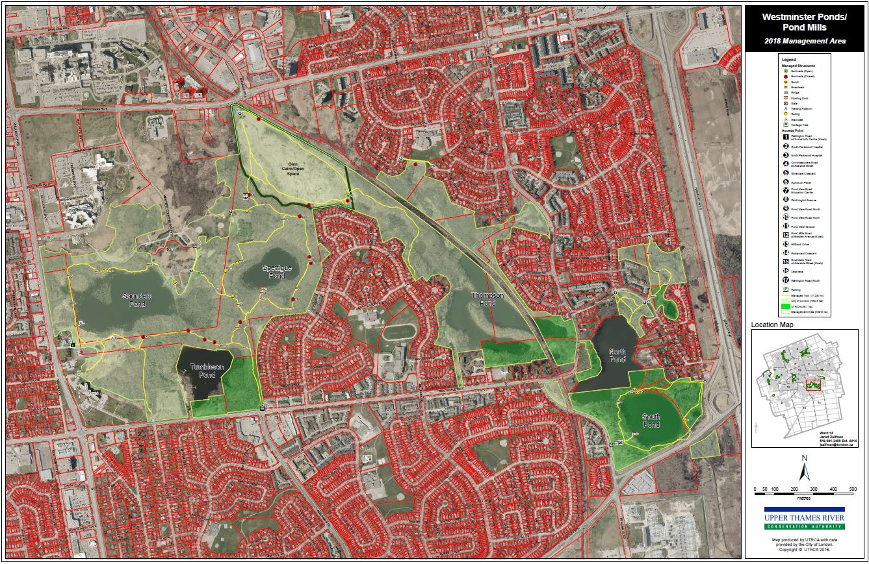Figure 12 Westminster Ponds / Pond Mills Environmentally Significant Area
Literature Cited
BioLogic. 1999. Kilally Open Space Master Plan. BioLogic, London, Ontario. URL: https://www.london.ca/city-hall/master-plans-reports/master-plans/Documents/ESA-Kilally-Open-Space-Master-Plan.pdf.

CCEA (Canadian Council on Ecological Areas). 2018. Protected Areas and Other Effective-Area-based Conservation Measures in Canada: A Guidebook for their Identification and for the Application of IUCN Protected Area Categories. Canadian Council on Ecological Areas, Ottawa, Ontario, Canada.

Conservation Ontario. 2011 (Updated 2013). Guide to Developing Conservation Authority Watershed Report Cards. Conservation Ontario, Newmarket, Ontario. 90p. [online] URL: http://www.nickeldistrict.ca/images/pdfs/guide_to_developing_conservation_authority_watershed_report_card.pdf .

Conservation Ontario. 2018. About Conservation Authorities. Conservation Ontario, Newmarket, Ontario. [online] URL: http://conservationontario.ca/conservation-authorities/about-conservation-authorities.

Cooke, T. 2019. Letter of Commendation to City of London. April 8, 2019. Invasive Species Centre. Sault Ste. Marie, Ontario. URL: https://www.london.ca/residents/Environment/Natural-Environments/Documents/Congratulating-City-of-London-Ltr.pdf.

Corporation of the City of London. 2011. Zoning By-law No. Z.-1. City of London, London, Ontario. URL: https://www.london.ca/business/Planning-Development/zoning-by-law/Pages/Z1-Zoning.aspx

Corporation of the City of London. 2018. Parks and Recreation Area By-law PR-2-18004. City of London, London, Ontario. URL: https://www.london.ca/business/Planning-Development/zoning-by-law/Pages/Z1-Zoning.aspx

Corporation of the City of London. 2017. London Invasive Plant Management Strategy. City of London, London, Ontario. UTL: https://www.london.ca/residents/Environment/Natural-Environments/Documents/Invasive_Plant_Management_Strategy.pdf

Corporation of the City of London. 2016. London Plan. Corporation of the City of London, London, Ontario. URL: http://www.london.ca/business/Planning-Development/Official-Plan/Documents/2019-London-Plan/The-London-Plan-Policies-in-Effect-July-22-2019-r.pdf .

Corporation of the City of London. 2016. Guidelines for Management Zones and Trails in Environmentally Significant Areas. Corporation of the City of London, London, Ontario. URL: file:///C:/Users/lmcdouga/Downloads/Guidelines_for_Trails_in_ESAs%20(20).pdf .

Corporation of the City of London. 2007. Environmental Management Guidelines. Corporation of the City of London, London, Ontario. URL: https://www.london.ca/business/Resources/Consultant-Resources/Pages/Environmental-Guidelines.aspx.

Corporation of the City of London and UTRCA (Upper Thames River Conservation Authority). 2016. Sifton Bog Environmentally Significant Area
Conservation Master Plan 2009 - 2019. Corporation of the City of London and Upper Thames River Conservation Authority, London, Ontario. URL: https://www.london.ca/city-hall/master-plans-reports/master-plans/Documents/SiftonBog-CMP.pdf.

Corporation of the City of London and UTRCA (Upper Thames River Conservation Authority). 2005. Westminster Ponds /Pond Mills Environmentally Significant Area Master Plan Update. Corporation of the City of London and Upper Thames River Conservation Authority, London, Ontario. URL: https://www.london.ca/city-hall/master-plans-reports/master-plans/Documents/ESA-Westminster-Ponds-Master-Plan.pdf.

Dillon Consulting Limited. 2015. Natural Heritage Inventory and Evaluation Medway Valley Heritage Forest ESA. Dillon Consulting Limited, London, Ontario. URL: http://www.london.ca/residents/Environment/Natural-Environments/Documents/Medway%20NHI-Eval-Final%20Report-Public%20Use-Jan2015.pdf.

Dudley, N. (Editor). 2008. Guidelines for Applying Protected Area Management Categories. Gland, Switzerland: IUCN. x + 86p. WITH S. Stolton, P. Shadie, and N. Dudley (2013). IUCN WCPA Best Practice Guidance on Recognising Protected Areas and Assigning Management Categories and Governance Types, Best Practice Protected Area Guidelines Series No. 21, IUCN, Gland, Switzerland. [online] URL: https://cmsdata.iucn.org/downloads/guidelines_for_applying_protected_area_management_categories.pdf.

Environment and Climate Change Canada. 2017. Recovery Strategy for the False Rue-anemone (Enemion biternatum) in Canada. Species at Risk Act Recovery Strategy Series. Environment and Climate Change Canada, Ottawa. vii + 27 pp. URL: http://publications.gc.ca/collections/collection_2018/eccc/En3-4-284-2017-eng.pdf

MMAH (Ministry of Municipal Affairs and Housing). 2014. Provincial Policy Statement under the Planning Act. Queen’s Printer for Ontario. 50p. [online] URL: www.mah.gov.on.ca/AssetFactory.aspx?did=10463.

MNRF (Ministry of Natural Resources and Forestry). 2017a. Conserving Our Future: A Modernized Conservation Authorities Act. Ministry of Natural Resources and Forestry, Toronto, Ontario. 34p. [online] URL: www.lsrca.on.ca/.../board/ConservingOurFuture_final%20draft.pdf.

MNRF (Ministry of Natural Resources and Forestry). 2017b. A Wetland Conservation Strategy for Ontario 2017-2030. Queen’s Printer for Ontario. Toronto, Ontario. 52p. [online] URL: https://files.ontario.ca/mnr_17-075_wetlandstrategy_final_en-accessible.pdf.

North South Environmental. 2014. Conservation Master Plan for the Coves ESA. North South Environmental Inc., Campbellville, Ontario. [online] URL: http://www.london.ca/business/Planning-Development/Official-Plan/Documents/2019-London-Plan/The-London-Plan-Policies-in-Effect-July-22-2019-r.pdf.

Natural Resource Solutions. 2019. Meadowlily Woods Environmentally Significant Area Conservation Master Plan, Phase 1. Natural Resource Solutions, Waterloo, Ontario. [online] URL: http://www.london.ca/residents/Environment/Natural-Environments/Documents/Meadow-EnvironManageStrategy-Final.pdf.

NHIC (Natural Heritage Information Centre). 2003. NHIC Database. Ministry of Natural Resources, Peterborough, Ontario. [online] URL: www.ontario.ca/page/natural-heritage-information-centre.

Parsons and North South Environmental Inc. 2019. Ecological Restoration Plan for Kilally Meadows Environmentally Significant Area. Parsons Inc and North South Environmental Inc.., Campbellville, Ontario. [online] URL: http://www.london.ca/business/Planning-Development/Official-Plan/Documents/2019-London-Plan/The-London-Plan-Policies-in-Effect-July-22-2019-r.pdf.

Statutes of Ontario. 1990a. Conservation Authorities Act, RSO 1990, c.27. [online] URL: www.ontario.ca/laws/statute/90c27.

Statutes of Ontario. 1990b. Mining Act, R.S.O. 1990, c. M.14. [online] URL: www.ontario.ca/laws/statute/90m14?search=e+laws.

UTRCA (Upper Thames River Conservation Authority). 1952. Upper Thames Valley Conservation Report 1952. Department of Planning and Development, Toronto, Ontario. [online] URL: http://thamesriver.on.ca/wp-content/uploads//Publications/52Report-Contents-Intro-Recommendations.pdf.

UTRCA (Upper Thames River Conservation Authority). 2006. Environmental Planning Policy Manual for the Upper Thames River Conservation Authority, London, Ontario. Accessed 21 September 2017. [online] URL: http://thamesriver.on.ca/planning-permits-maps/utrca-environmental-policy-manual/.

UTRCA (Upper Thames River Conservation Authority). 2016. Environmental Targets: Strategic Plan June 2016. Upper Thames River Conservation Authority, London, Ontario. 13p. [online] URL: http://thamesriver.on.ca/wp-content/uploads//Targets/EnvironmentalTargets-June2016.pdf.

UTRCA (Upper Thames River Conservation Authority). 2017. 2017 Upper Thames River Watershed Report Cards. Upper Thames River Conservation Authority. Principle Authors: Cathy Quinlan and Karen Maaskant 12p. [online] URL: http://thamesriver.on.ca/wp-content/uploads//WatershedReportCards/S1-Report.pdf.
UTRCA (Upper Thames River Conservation Authority). 2018. Upper Thames River Watershed Report Card – Summary 2017. 8p. Upper Thames River Conservation Authority, London, Ontario. [online] URL: http://thamesriver.on.ca/wp-content/uploads//WatershedReportCards/UTRwatershedreportcard-summary2018.pdf .

